**Participant Enrolment Form**

***Your enrolment will not be accepted unless a 50% deposit is paid upon booking and the course fees are paid in full by the Wednesday prior to the commencement of each Block***

NAME: _______________________________

________________________________________

ADDRESS: ___________________________

________________________________________

PHONE: ______________________________

AGE: __________________________________

EMAIL: _______________________________

________________________________________

WATER SAFETY WEEK COURSE

Tick one/or both

BLOCK 1 (DEC 2017) ☐

BLOCK 2 (JAN 2018) ☐

FULL PAYMENT OF

$________ IS ENCLOSED.

* Cash/Eftpos/Credit Cards

at the Centre or by Phone

**The Program**

The Water Safety Week Program is an alternative to traditional aquatic programs. The activities focus on fun and aquatic skill development based on personal best achievements. Building on skills they already have, Water Safety Week members work to develop and improve swimming and other aquatic skills with emphasis on:

* Swimming Skills
* Water Safety
* Lifesaving Techniques
* Personal Fitness
* Community Education
* Lifesaving Knowledge
* Leadership & Teamwork

The Water Safety Week Program is water based. These activities are complimented with community education projects and dry land fun such as:

* Games
* Displays
* Demonstrations
* Discussions

**Course Information**

The Program runs for 1 week over the School Holidays - Monday to Thursday 9am – 12pm and finishing on Friday at 12.30pm with the Presentation and a BBQ sausage sizzle.

**Cost:**

**1 week course: $95 / person**

**Ages: 5 – 15 years**

**What to Bring:**

* Hat
* Togs
* Towel
* Water Bottle
* Morning Tea/snacks
* Long Clothes to Swim in (e.g. Long PJs)
* Change of clothes to go home in

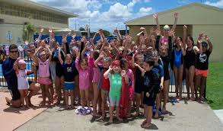

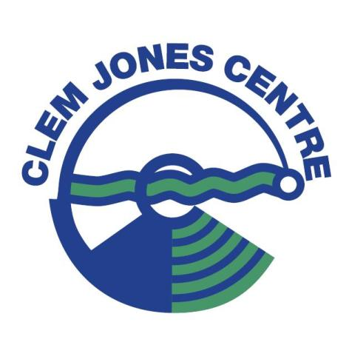



**Cancellation Conditions**

Any Course may be cancelled by the Clem Jones Centre due to insufficient enrolments or other unforeseen circumstances.

If a participant cancels from a course, refunds of the course costs will only be considered upon presentation of a Medical Certificate.

**COURSE DATES**

**1ST WEEK BLOCK**

**11th – 15th December 2017**

**2nd WEEK BLOCK**

**15 – 19th January 2018**

**LIMITED PLACES AVAILABLE**

**Your Coach**

The Water Safety Week Coach must have the following qualifications:

* Hold a Current RLSSQ Pool Lifeguard award
* Have experience as a Lifeguard
* Have previous coaching / leadership experience
* Hold a Current Child Safety Blue Card
* Hold a Current CPR and First Aid award

**The Fun**

The Water Safety Week Program offers an aquatic alternative to those kids who love the water and want more than just lessons.

The Water Safety Week Program keeps kids interested and active in aquatics – especially quick learners and those caught in between levels and programs.

The Water Safety Week Program is designed for participants with differing abilities and ages to join together for learning and fun.

No one fails in the Water Safety Week Program. Participants enjoy high energy activities in a learning environment where personal efforts and success are recognised. Each participant receives the Nationally Recognised ‘Swim and Survive’ Certificate.

