

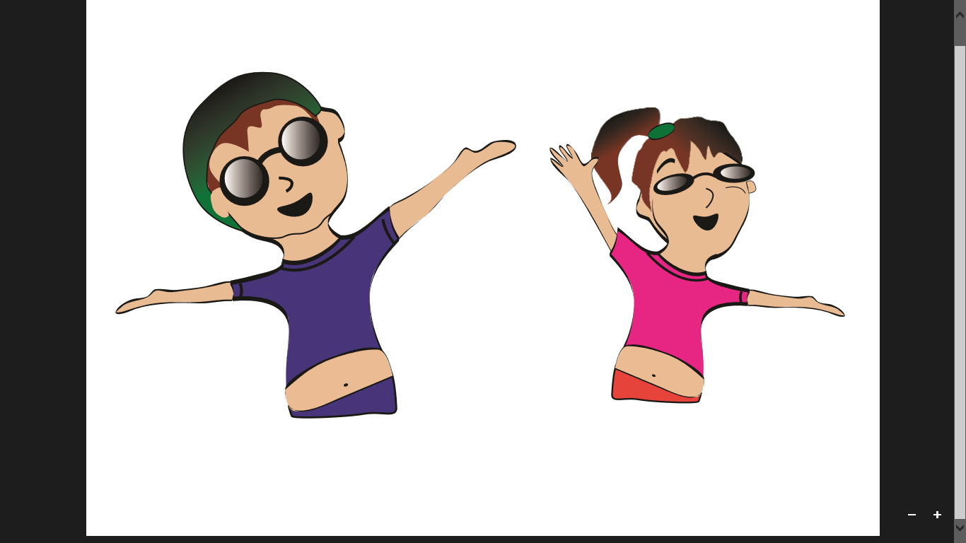
HOLIDAY BLOCK
SUMMER SWIMMING

DECEMBER :
Monday 11th December – Friday 15th December 2017

January:
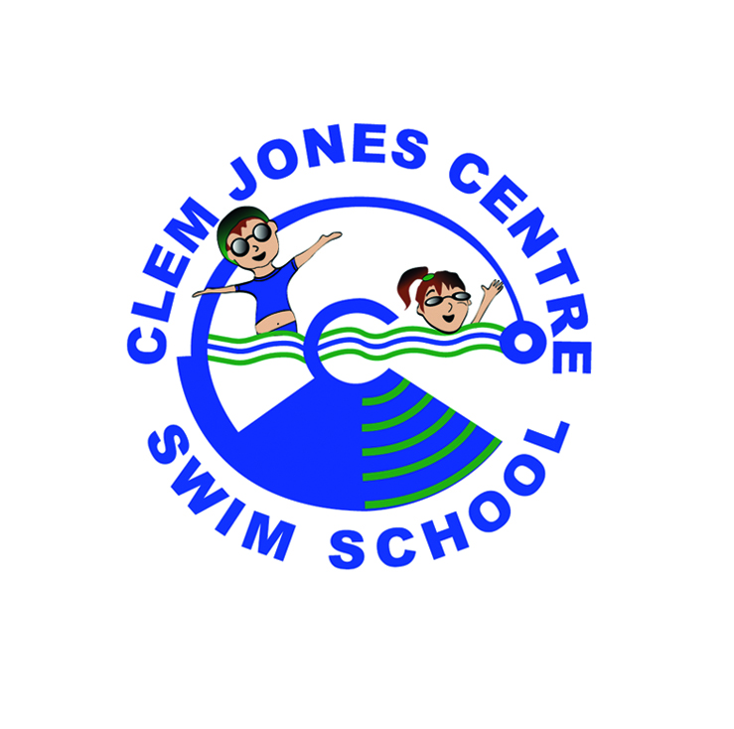
Monday 15th January – Friday 19th January 2018

Cost $75 per child
(5 day block)

If you would like your child/children to participate in one or both of the above Holiday Blocks, please note your details on the registration form located on the Learn to Swim counter.

Conditions of holiday block enrolment:
- Enrolment is for every day of the week
- Mornings Classes Only
- No discounts apply
- No Make Ups available for lessons missed during the week

