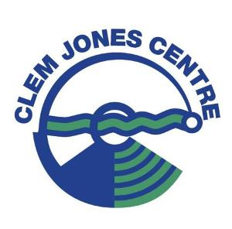

**Clem Jones Centre Juniors & Intermediates Swim Squads**

**December/January Schedule**

Please take note of the important training changes for the upcoming December/January holiday period.

**Training Schedules**

|  |  |  |  |
| --- | --- | --- | --- |
| **December 2017** | | | |
| **Week** | **Dates** | **Training** | **Other** |
| 1 | 27/11 – 2/12 | NORMAL SCHEDULE |  |
| 2 | 4/12 – 9/12 | NORMAL SCHEDULE | No Saturday morning session |
| 3 | 11/12 – 16/12 | Afternoon Sessions ONLY | No Saturday morning session |
| 4 | 18/12 – 23/12 | Afternoon Sessions ONLY | No Saturday morning session |
| 5 | 25/12 – 30/12 | NO TRAINING |  |

|  |  |  |  |
| --- | --- | --- | --- |
| **January 2018** | | | |
| **Week** | **Dates** | **Training** | **Other** |
| 1 | 2/1 – 6/1 | Afternoon Sessions ONLY | No Saturday morning session |
| 2 | 8/1 – 13/1 | Afternoon Sessions ONLY | No Saturday morning session |
| 3 | 15/1 – 20/1 | NORMAL SCHEDULE |  |
| 4 | 22/1 – 27/1 | NORMAL SCHEDULE | No Training Australia Day |

**Fees & Pricing**

Regular fee pricing remains, but will cover 2 month period (December & January). Fees are to be paid on the first day of attendance during this period.

Any questions are to be directed to Head Coach – Brian Glass.

Email: [brian@clemjonescentre.com.au](mailto:brian@clemjonescentre.com.au)